Instructions:

* Open book
* Please no talking
* Instructor cannot assist
* The exam must be submitted before **9pm.**

Good luck!

**There are 5 print screens, each worth 20%**

**Project #1 (Based on Chapter 5 Methods) Be sure to create the calculateRetail method in the main method class) only 1 class needed for this section.**

Complete the following below:

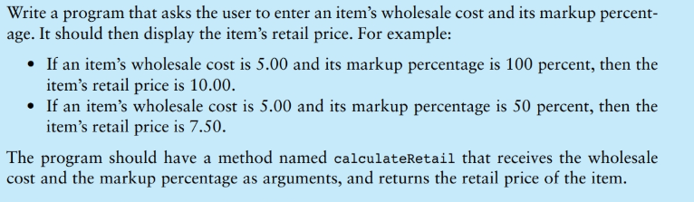

**#1 print screen the output with the code below here**

**Project #2 (Based on Chapter 6 Classes - Mutators and Accessors) be sure to create two separate classes for this section**

Complete the following below:

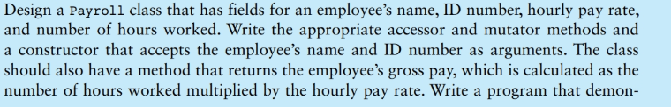

**#2 print screen the output with the code below here for the two classes.**

**Project #3 (Based on Chapter 7 (Arrays) – use System.out as the output for the arrays**

1. Write a 1-D array that will output the numbers 1-10 then sum and average the numbers

**#3 print screen the output with code below here.**

1. Write a 2-D array that will output the numbers 1-12 then sum and average the numbers

**#4 print screen the output with code below here.**

1. Write a 3-D array that will output the numbers 1-9 then sum and average the numbers

**#5 print screen the output with code below here.**

**Submit this document to Module 8 Final Exam**

**Thank you everyone! I wish everyone only goodness, happiness, and health.**